SURVEY REST API

Hi, This is a Survey Application created by Yash Raghava.

Here the User can post Questions and create a manual Survey.The Questions and Answers can be fetched through REST API.

Each Survey consist of a number of Questions.

Each Question has a number of options and one correct option.

The Dependencies used in the Spring Application are –

Spring Boot Starter Web, Spring Boot Starter Validation, Spring Boot Starter Data Jpa, Spring Boot Starter Security

The Application uses an InMemory H2 Database for storing Data.

APPLICATION SCREENSHOT

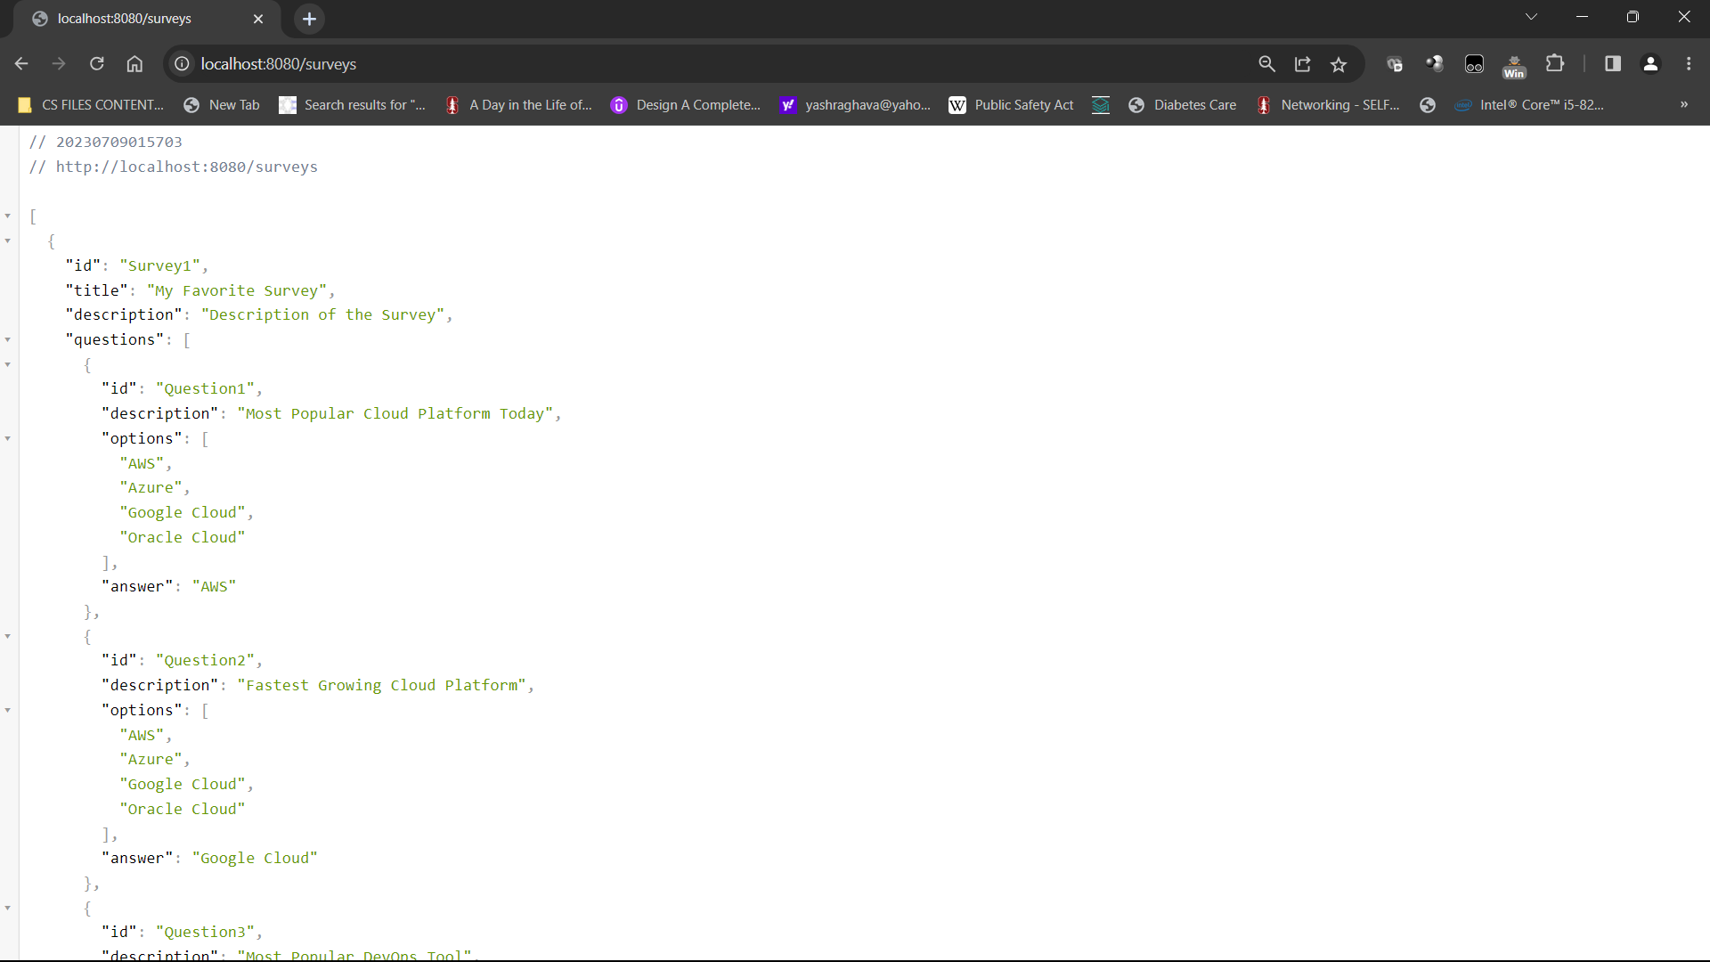

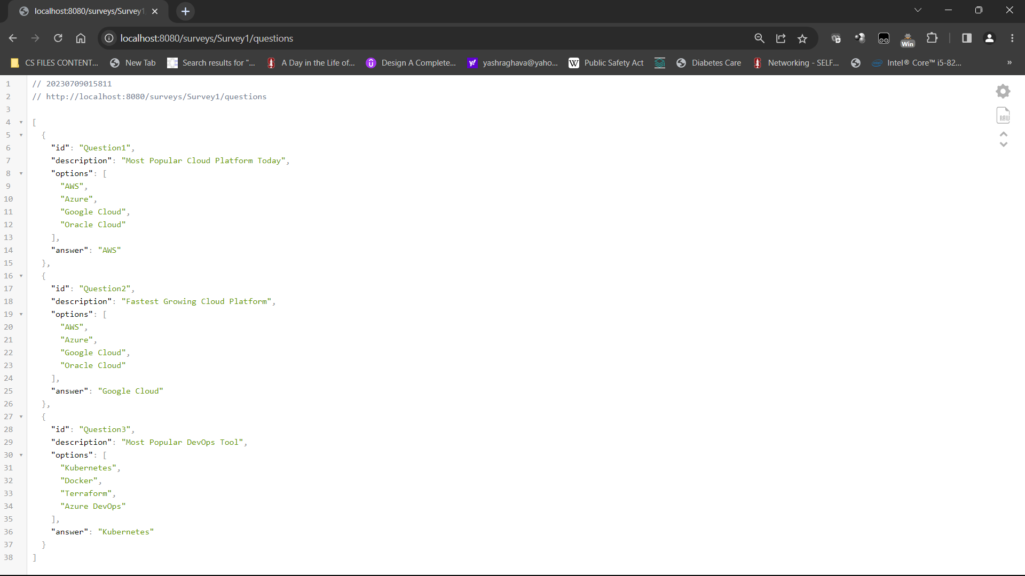

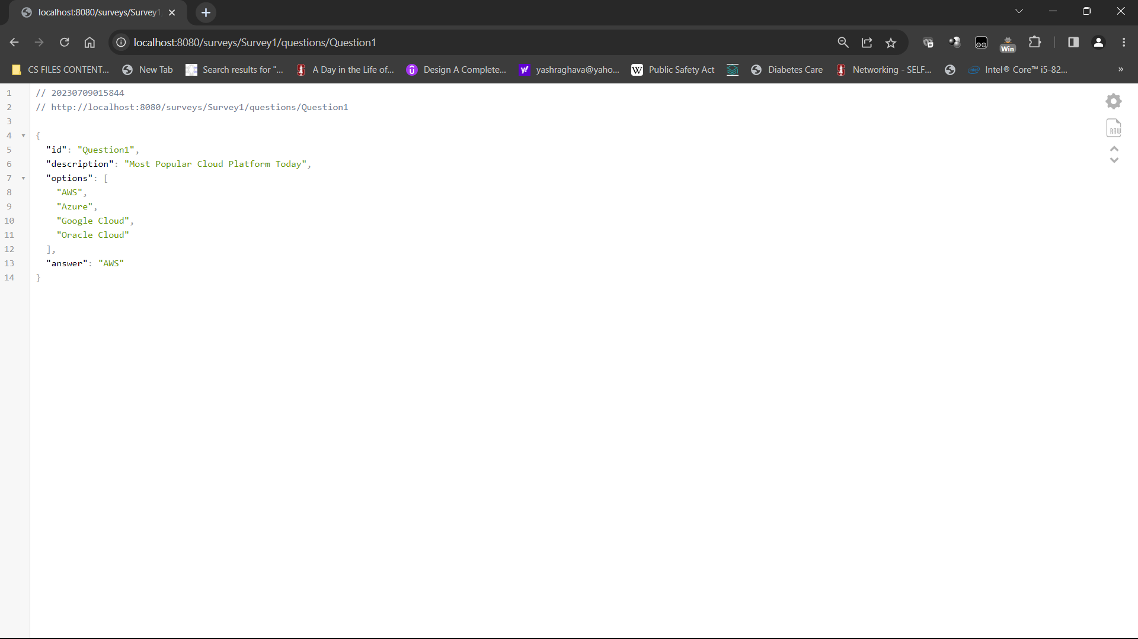

SWAGGER OPEN API SCREENSHOT

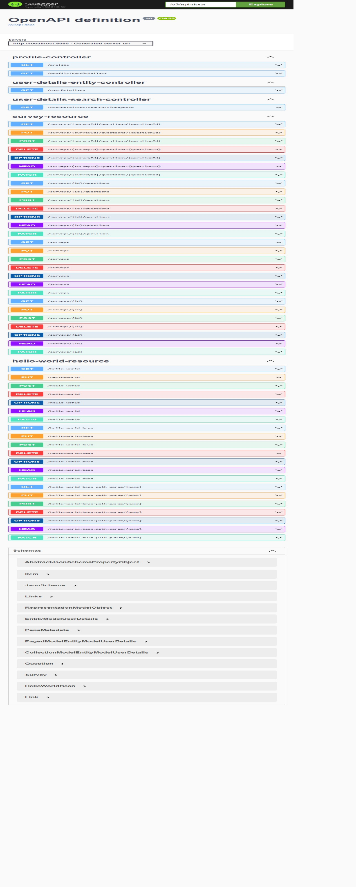

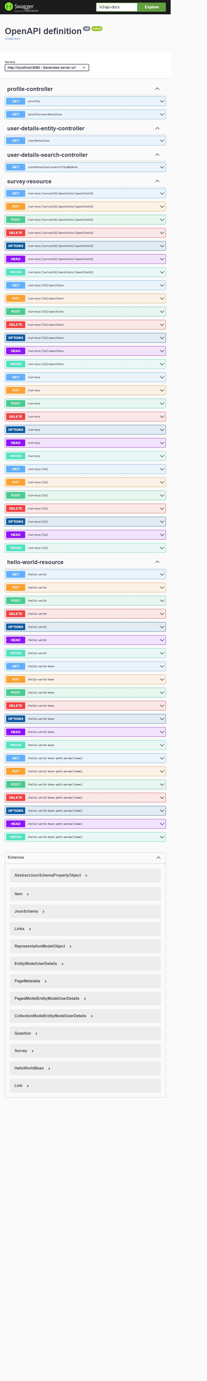



HAL EXPLORER SCREENSHOT

